**Computing, Year 3**

**Rich Web Applications**

**Lab sheet 4**

**Exercise 1 – Previewing Links**

Going back to lab sheet 1 exercise 3:

In this exercise display any 3 book cover photos from any website, eg amazon.com.

When the user double clicks on any photo, a smaller web page is displayed giving a quick synopsis about the book selected.

Now when the user hoovers over a book image a mini-preview about the book is displayed using AJAX techniques.

**Exercise 2 – Reading a JSON file using AJAX**

Using AJAX techniques, display the following invoice file as a JSON text file in the browser.

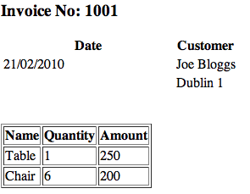

**Exercise 3 – Dynamic Forms (Autocomplete)**

Create a JSON file containing all the counties in Ireland with labels,

Eg label: “Dublin”, value “Du”, etc.

Using AJAX and this JSON file, create an autocomplete form so that when the user starts typing a pop-up box appears with suggested completions.

**Exercise 4 – Autocomplete using a PHP file**

Returning to exercise 3 on labsheet 3, instead of using a JSON file use a PHP file to create an autocomplete example as follows:

Create a PHP file containing all the counties in Ireland with labels,

Eg label: “Dublin”, value “Du”, etc.

Using AJAX and this PHP file, create an autocomplete form so that when the user starts typing a pop-up box appears with suggested completions.

**Exercise 5 – AJAX Database Example**

Returning to labsheet 2, Q1 part c

*You and a friend are travelling to Rome in Italy. You are flying from Dublin to Italy on March 4th, departing from Dublin at 12.15pm and arriving in Rome at 15.25pm. You are staying for one week and leave Rome on 11th March at 16.05pm arriving in Dublin at 17.20pm. You are staying in the Radisson Hotel for 7 nights.*

Create a mini-application using PHP, AJAX and MySQL so that the user can display the above details from a database file – you decide on the design……